|  |
| --- |
|  |
| RunTime T-Errors  Documentation: Bulky |
| |  |  |  | | --- | --- | --- | | Hlonipho Nersely | 10/21/22 | Development Software 2B | |

Table of Contents

GROUP MEMBERS NAMES 3

Roles 4

HN BILA (Business Analyst, Designer) 4

NM YINGWANI (Software tester) 4

T GADIPEDI (Developer, Designer) 4

A MARANJANA (Team [Project] Leader, Developer) 5

BO MAKGOPA (Usability, Developer) 5

J MARUPING (Database Admin, Developer) 5

PROBLEM 6

Supporting articles 6

Solution 7

Solutions: 7

Impacts: 7

SYSTEM ARCHITECTURE 8

USE CASE DIAGRAM 9

UML DIAGRAM 10

SCREEN MOCKUPS & LAYOUTS 11

APIs 23

PlacesAPI 23

GeocodingAPI Geocoding is the process of converting addresses (like "1600 Amphitheatre Parkway, Mountain View, CA") into geographic coordinates (like latitude 37.423021 and longitude -122.083739), which you can use to place markers on a map, or position the map. expo-location allows reading geolocation information from the device. Your app can poll for the current location or subscribe to location update events. Geolocation requests are sent using POST to the following “*URL:https://www.googleapis.com/geolocation/v1/geolocate?key=YOUR_API_KEY”* You must specify a key in your request, included as the value of a key parameter. A key is your application's API key. This key identifies your application for purposes of quota management Checks user's permissions for accessing location while the app. 24

Algolia search API 25

EmailJS API 26

PayFast API 27

Native Notify API 28

REFERENCES 29

# GROUP MEMBERS NAMES

|  |  |  |  |
| --- | --- | --- | --- |
|  | **NAMES** | **SURNAMES** | **STUDENT NO** |
|  | Hlonipho Nersley | Bila | 220080694 |
|  | Mogomotsi Thato | Gadipedi | 221028477 |
|  | Ndzulamo Michelle | Yingwani | 220122253 |
|  | Axole | Maranjana | 220023913 |
|  | Ofentse Bethuel | Makgopa | 221066447 |
|  | Junior | Maruping | 221023858 |

# Roles

### HN BILA (Business Analyst, Designer)

A Business Analyst is a person who processes, interprets, and documents business processes, products, services, and software throughout analysis of data. The role of the business analyst is to ensure business efficiency increases through their knowledge of both IT and business function. Business analysts assess how organizations are performing and help them improve their processes and systems. They conduct research and analysis to come up with solutions to business problems and help to introduce these solutions to businesses and their clients. She is doing Documentation where she is defining the problem and solutions and its impacts, also giving the clarification of an app, which may help the end users to understand what and how the App Is working and how it has been structured and been done.

### NM YINGWANI (Software tester)

A software tester is an individual who uses their skills and expertise with computers to make sure certain computer programs operate as intended. They often work to ensure that all the software functions operate smoothly, no bugs are present in the final product and help identify any holes in the program's security. This can help companies and businesses provide a helpful product to consumers and protect the software from any cyber-attacks. Software testers can perform their duties manually or use coding and automated tools to help them test computer programs more efficiently.

Create a profile page that consists of user’s personal information, contact details and the balance in their wallet. The users use the money the is in the balance section to purchase what they want to buy. There will also be saved login info, data and log out option.

### T GADIPEDI (Developer, Designer)

The role of a designer is to design the mobile app application UI to give the user the user the feel of the app in terms of how it will look and how the user will navigate through the app .My main goal was to make the app stand out with its unique design and UI that will draw the in the user’s attention ,I had to ensure that navigation is well structured, the use of tab bars , navigation control, screens of content and modal views are well put out to ensure the user’s basic interaction with the app runs smoothly.

### A MARANJANA (Team [Project] Leader, Developer)

The role of a project leader is to ensure that a project is completed on time, within budget, and to the required standard. They are responsible for planning, coordinating, and monitoring the progress of a project and for ensuring that any risks are identified and managed. Also was reviewing the codes that they match the overall theme and feel for the app also made sure everything pushed to GitHub repo was not going to break the current app we had and also

### BO MAKGOPA (Usability, Developer)

App usability is the measure of how easy it is for users to interact with an app and ensure that users can easily find the features they need and complete tasks without difficulty. The address screen was created by me so that users could enter their address easily and also use my current location.

### J MARUPING (Database Admin, Developer)

Mostly did the front end of the app but created the database and the relationship between the tables, where the data will be stored. Also doing the code for the Search screen and designing it using some bootstrap elements, where when a user wants to search for products, they want to purchase they can go there to check for the products availability. Customers can also search for products by category, with an API provided to give users their results instantly within a short period of time when they search for any items of their desire. Assisted with finishing up the documentation. Played a role in designing the app and applied some API to the app.

# PROBLEM

Food prices keep on increasing and it’s hard for students to afford their basic needs since their allowance never increase, which leads to:

* Lacking basic human needs
* Mental health problems
* Lack of concentration

### Supporting articles

* <https://tradingeconomics.com/south-africa/food-inflation>

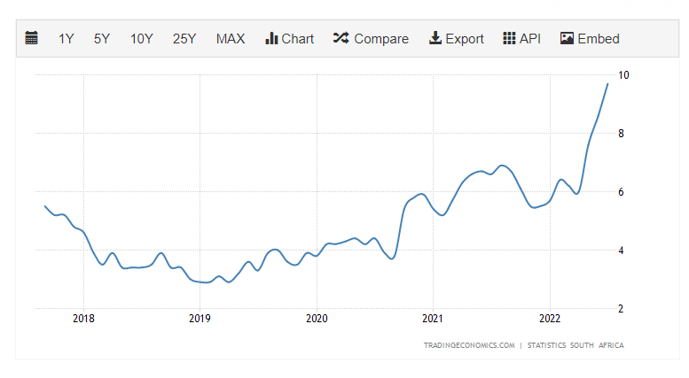

Food inflation in the last 5 years.

* <https://businesstech.co.za/news/lifestyle/523844/how-food-prices-have-changed-in-south-africa-over-the-last-5-years/>
* <https://www.statista.com/statistics/370516/unemployment-rate-in-south-africa/>

# Solution

To create an app as a platform for varsity students to buy groceries in groups, the groceries will be bought from the wholesalers with lower prices, then distributed amongst the students. The App will allow students to register their account with their basic information, have a wallet where they can load their balances then select food items and toiletries they want to the total of their balance. Then once a month the food items will be bought from wholesalers with lowest prices then deliver to the respective students to the respective residences.

### Solutions:

* Students will be able to afford more basic needs as well as have adequate necessities for longer period.
* Makes it easier for students to find and buy the products they need.
* Purchase items faster.
* Resulting in them being able to even save up money for other things.
* Students won’t have to travel to get food since food will be delivered in their residences.

### Impacts:

* Convenience.
* Increased buying power
* Better Prices.
* More Variety.
* More Control.
* Easy Price Comparisons.
* No Crowds.
* No Sales Pressure.
* Privacy for Discreet Purchases.

# SYSTEM ARCHITECTURE

# USE CASE DIAGRAM

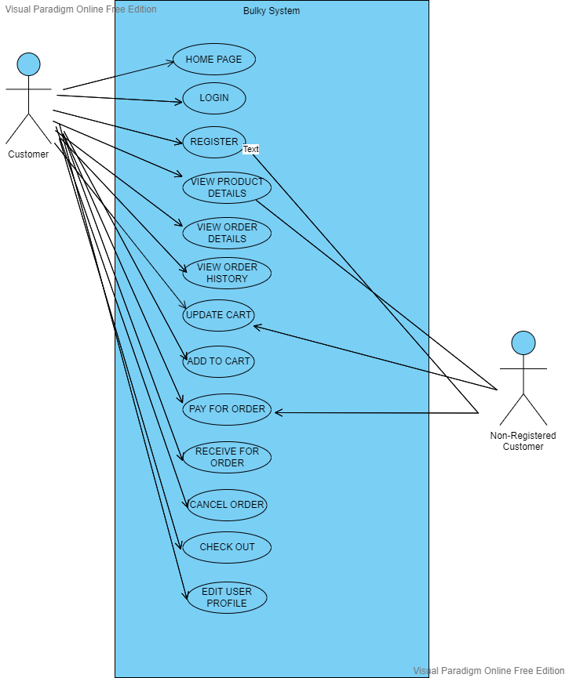

# UML DIAGRAM

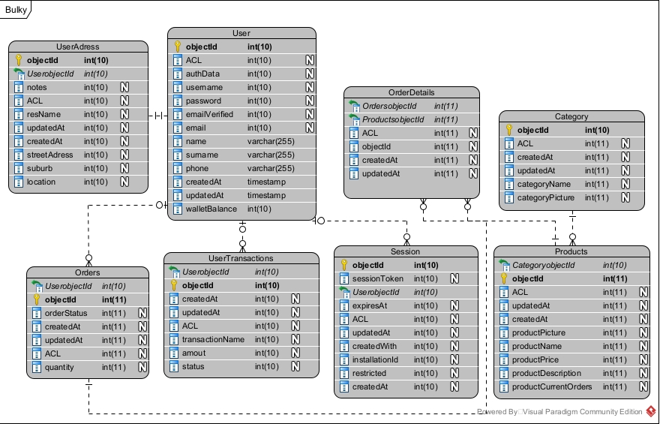

# SCREEN MOCKUPS & LAYOUTS

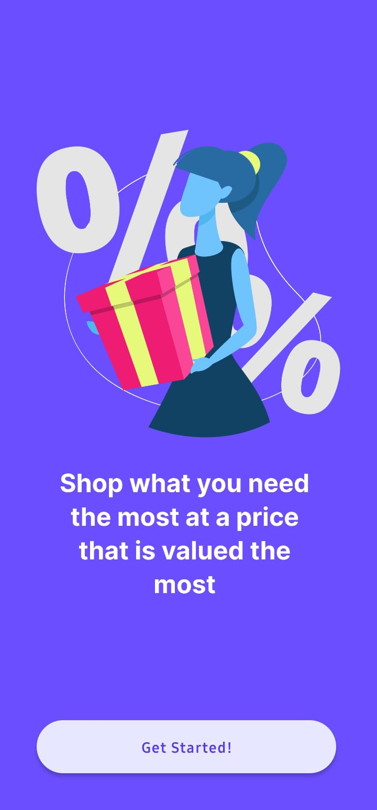

Start up page

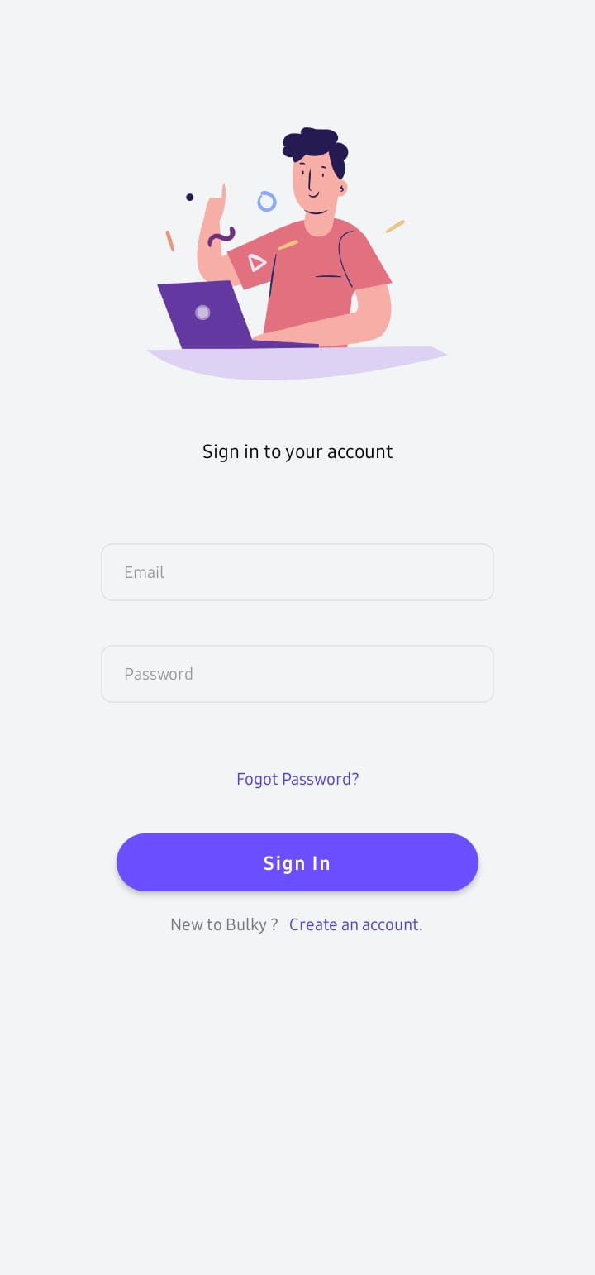

Navigate to forgot password screeen

Navigate to sign up page

Sign in button

Users password

Users email

Column layout

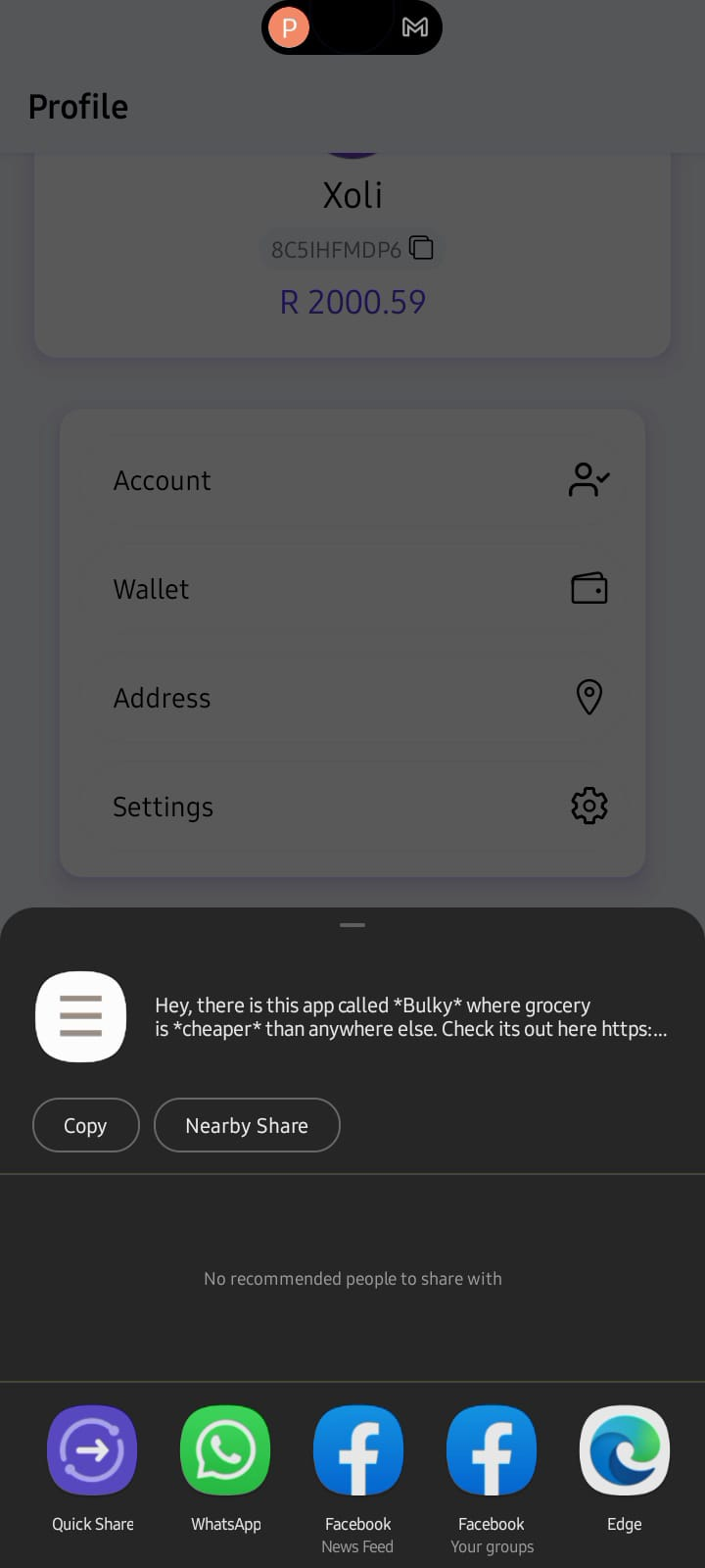

Sharing app options

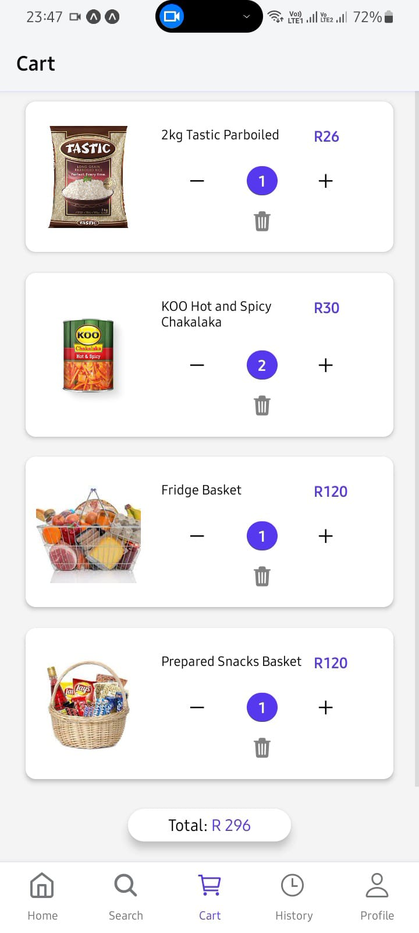

Total amount of items on the cart

Items on the cart

column layout

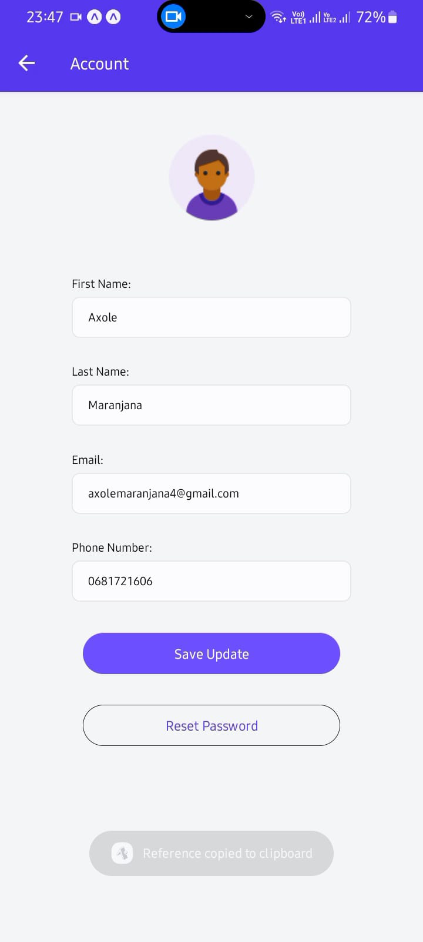

Success or error massage after an action

Avatar

Users name

Users contact

Users email

Users last name

Save Update&

Reset button

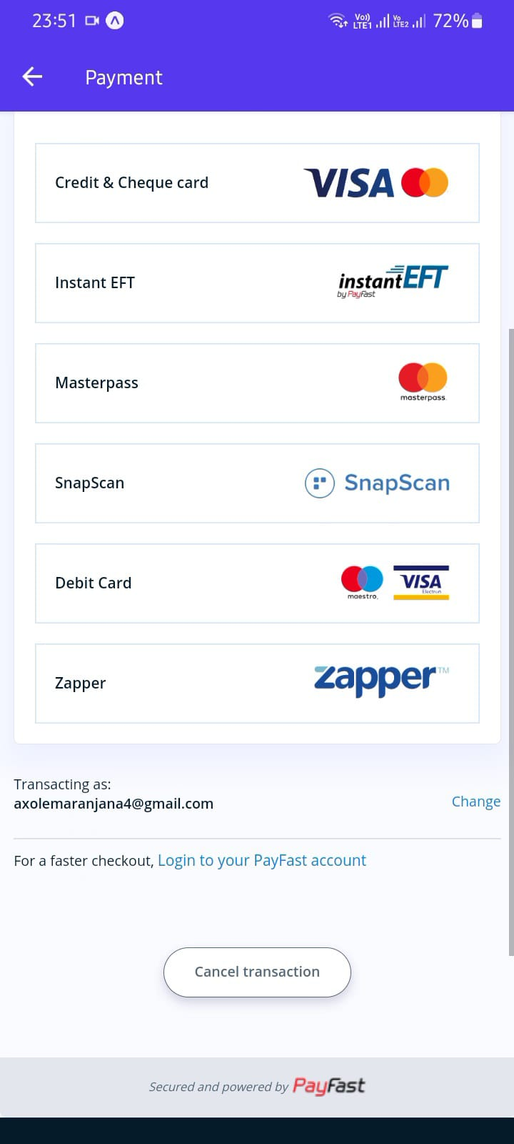

Cancel transaction button

Payment methods

current screen name

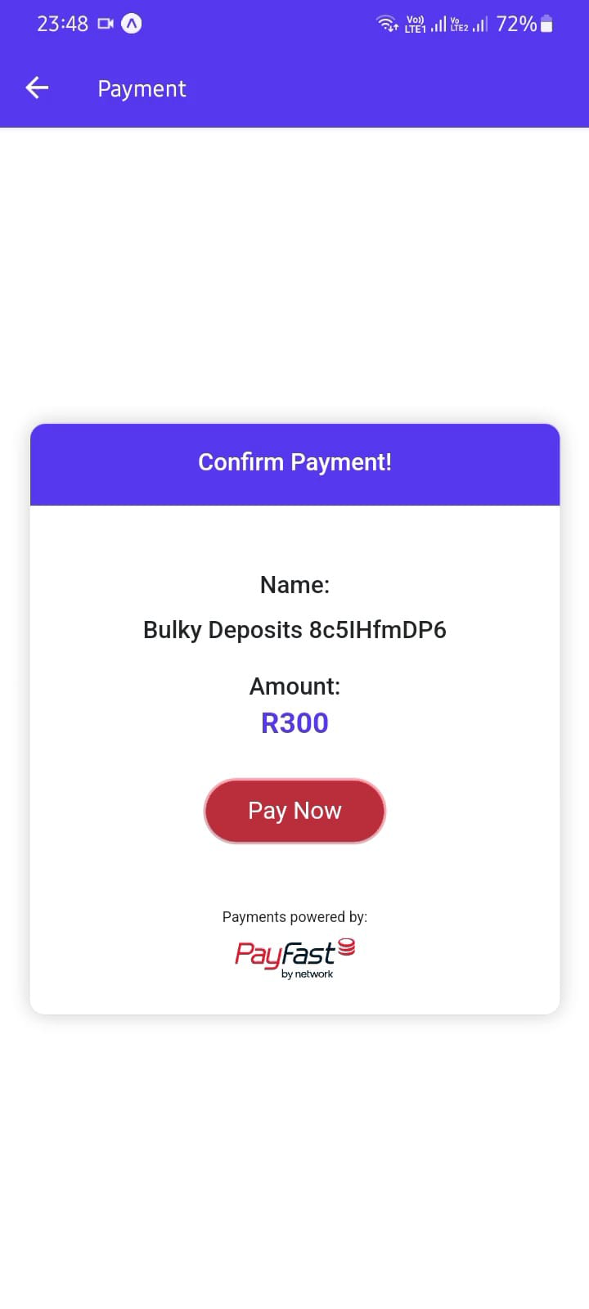

Confirm payment modal

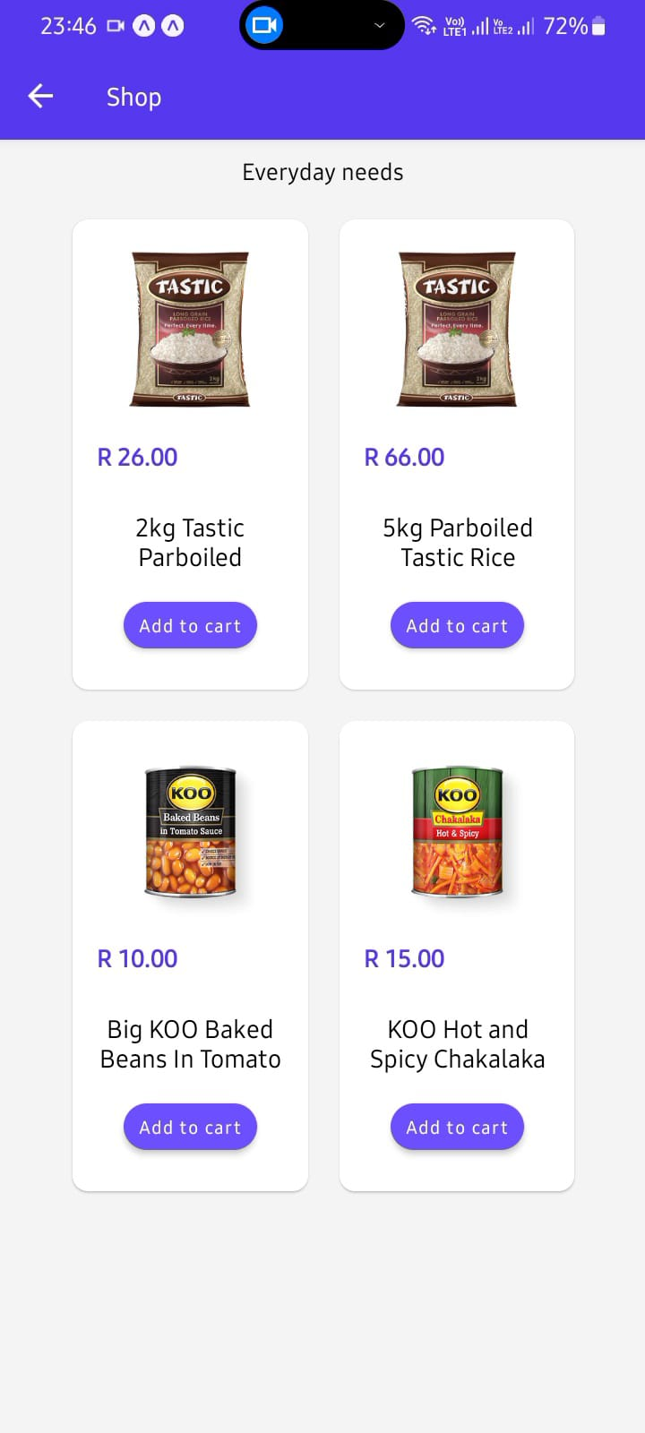

Product picture

Add to cart button

Product name

Product price

Product card

Grid layout

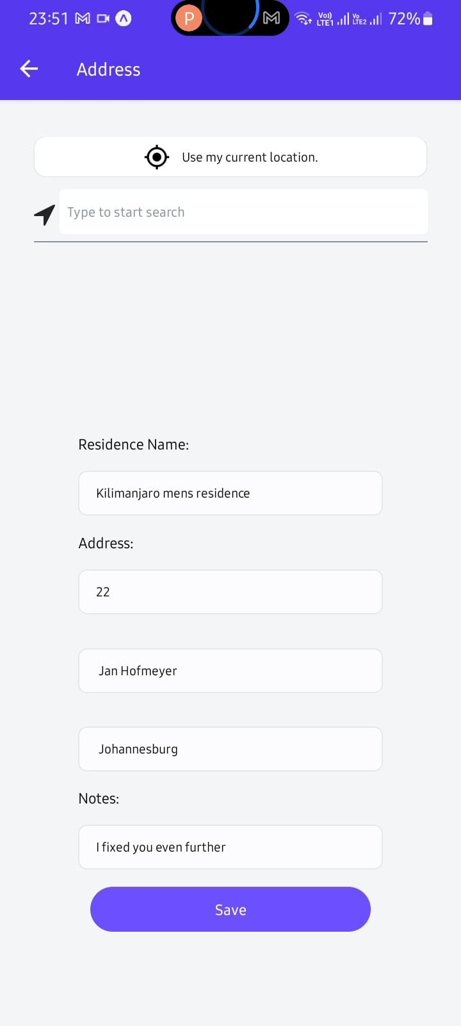

Back button

Use current location BTN for address input

Additional note for the address

Manual address input

Auto complete address input

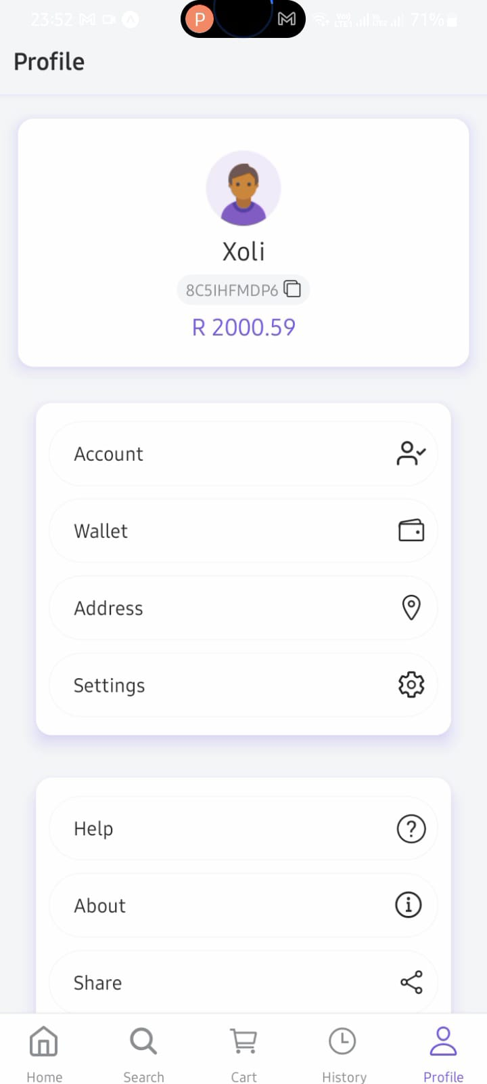

User current balance

User unique id

User’s name

Dummy avatar

Account

wallet

Address

Settings

Help

About

Share

Navigation links to the appropriate screen

Tab navigation

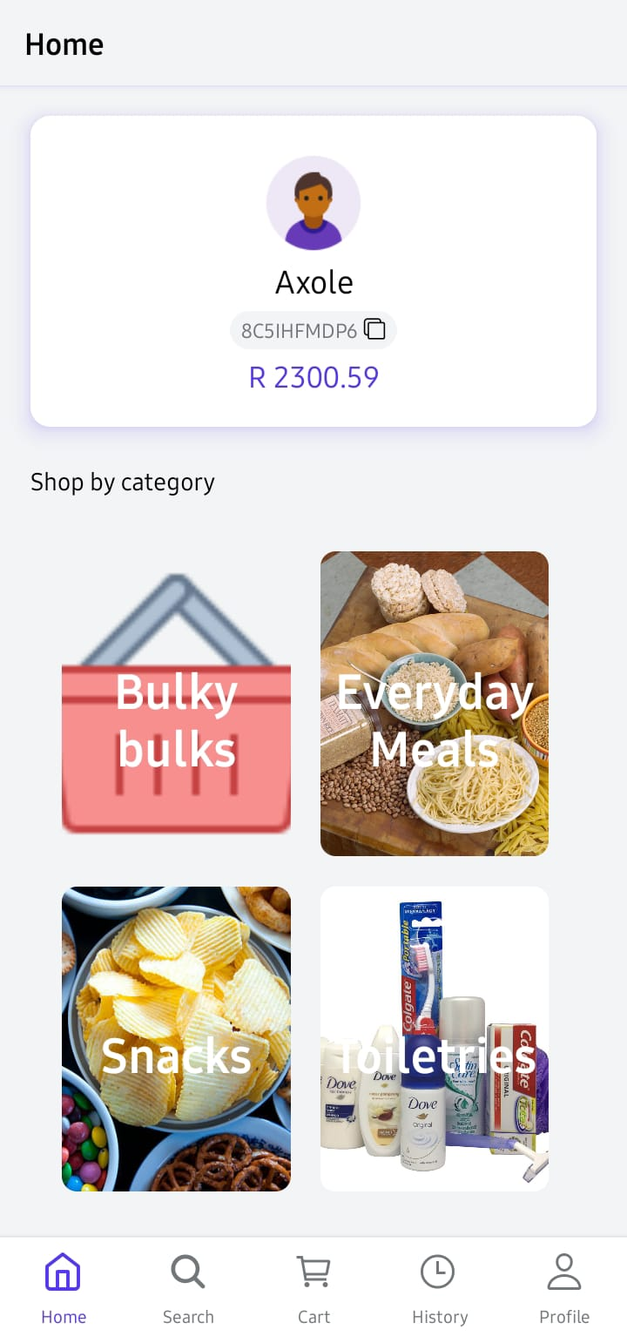

Shop by different Categories

Phone status bare

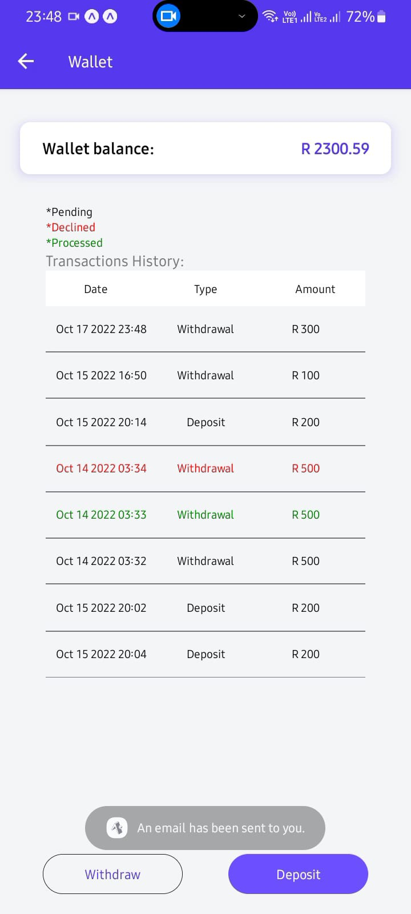

User transactions history and status of transaction

Deposit/Withdraw modal button

# APIs

### PlacesAPI

Using HTTP queries, the Places API is a service that provides data on locations. This API defines places as businesses, places in the world, or well-known tourist attractions. Each of the services can be accessed by an HTTP request, and the responses are either JSON or XML. Every request to a Places service must include an API key and be sent using the https:// protocol. A place ID is used by the Places API to identify a location specifically. Consult the Place IDs documentation for more information on the format and application of this identifier throughout the Places API and other APIs.

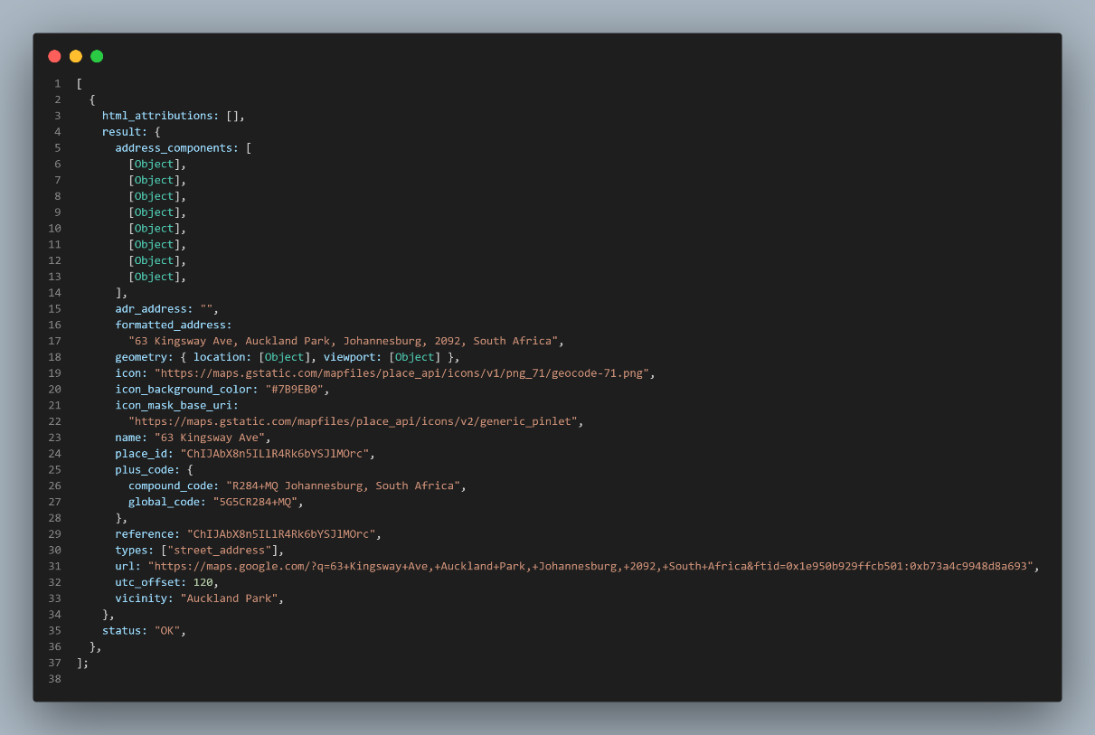

### GeocodingAPI Geocoding is the process of converting addresses (like "1600 Amphitheatre Parkway, Mountain View, CA") into geographic coordinates (like latitude 37.423021 and longitude -122.083739), which you can use to place markers on a map, or position the map. expo-location allows reading geolocation information from the device. Your app can poll for the current location or subscribe to location update events. Geolocation requests are sent using POST to the following “*URL:https://www.googleapis.com/geolocation/v1/geolocate?key=YOUR_API_KEY”* You must specify a key in your request, included as the value of a key parameter. A key is your application's API key. This key identifies your application for purposes of quota management Checks user's permissions for accessing location while the app.

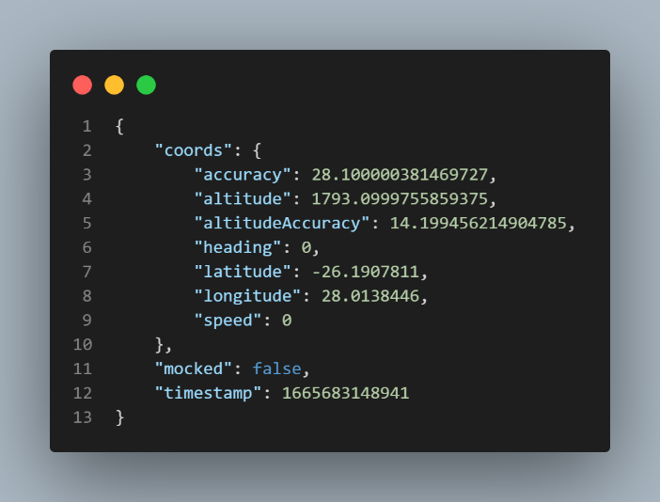

### Algolia search API

Algolia is a hosted search engine that provides full text numerical, faceted, and real-time results from the first keystroke. The search may be easily added to your website and mobile applications. The search API may give billions of inquiries for thousands of businesses and return pertinent results.

Sending your data to Algolia in the appropriate format is the first step. Once your data is on Aloglia's servers, you may begin testing search functionality. You can accomplish this either manually(code) or automatically by utilizing the dashboard or one of the certified API clients.

In our app we used Aloglia's React Instant Search Hooks. How it works on our app, it provides the search bar with multiple real-time results. It enables the user to be able to get numerous results instantly within a limited space of time.

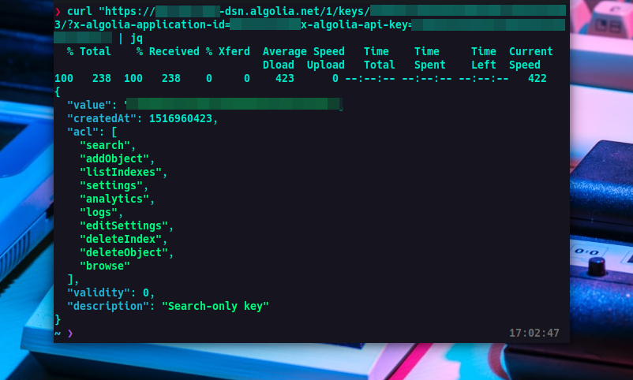

### EmailJS API

EmailJS is a service that allows us to send emails directly from your client-side JavaScript code. If we use EmailJS we don’t need a server to do that. It helps to send emails using client-side technologies only. No server is required – just connect EmailJS to one of the supported email services, create an email template, and use our JavaScript library to trigger an email. EmailJS is a platform that allows you tosend and receive emails without using a backend. The platform has a friendly user interface from which you can easily create email templates with dynamic parameters.

### PayFast API

|  |
| --- |
| An extensive RESTful API is being rolled out by PayFast. The management of subscriptions will be the first endpoint to be made public, and additional capabilities will follow soon.  With the help of the recurring service, businesses can set up two different types of repeating payments: a one-click ad hoc model where future due dates and amounts are uncertain, and a classic subscription model with a recurring charge on a specific date. Obtain the history of transactions for the specified time. |

### Native Notify API

Native Notify is a React Native Expo Push Notification service. Native Notify makes React Native Expo Push Notifications simple. With this native-notify plugin, you can send your first push notification in under 1 minute. Native Notify API sends push notifications to iOS and Android devices, redirect app users to specific screens once your push notification is tapped, send data with your push notifications, collect your push notifications in a Notification Inbox / App Inbox, track total number of views of each app screen, track unique number of users visiting each app screen.

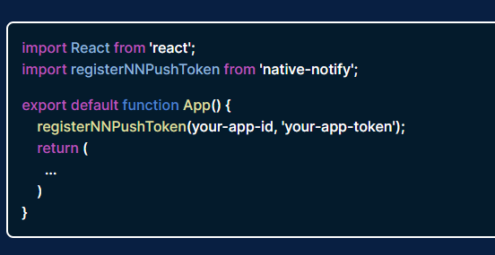

# REFERENCES

* Google - [Google Maps Platform | Google Developers](https://developers.google.com/maps/)
* React Native website - [React Native · Learn once, write anywhere](https://reactnative.dev/)
* Figma UI (App Design) - [Free, Online UI Design Tool & Software For Teams | Figma](https://www.figma.com/ui-design-tool/)
* PayFast - https://www.payfast.co.za
* Back4App - [Back4App - Low-code backend to build modern apps](https://www.back4app.com/)
* Redux - [Redux - A predictable state container for JavaScript apps. | Redux](https://redux.js.org/)
* Icons - [React Icons (react-icons.github.io)](https://react-icons.github.io/react-icons/)
* Expo - [Expo](https://expo.dev/expo-go)
* Supporting Articles for App Solution (Google) - <https://businesstech.co.za/news/lifestyle/523844/how-food-prices-have-changed-in-south-africa-over-the-last-5-years/><https://www.statista.com/statistics/370516/unemployment-rate-in-south-africa/>